LOGBOOK

# *1st DAY: SUNDAY*

We have arrived at about 12 am to the airport of Tallinn. The families that have hosted us were there to wait for our arrival.

My new Estonian friend came to me and introduced himself and his parents and, after a lot of photos of group with teachers and the other students, we went to his home by a beautiful car with his parents.

*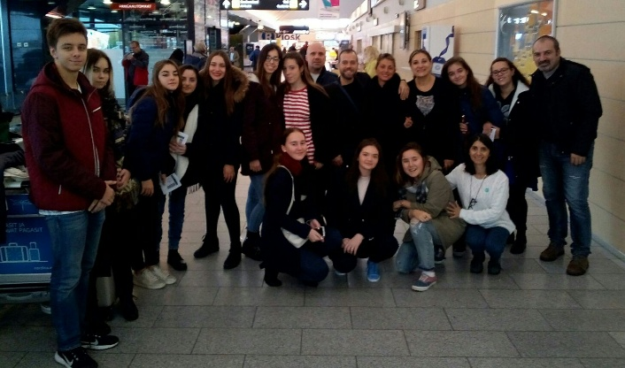(All together)*

Their house was great! Although it was small it was comfortable, and it was also warm.

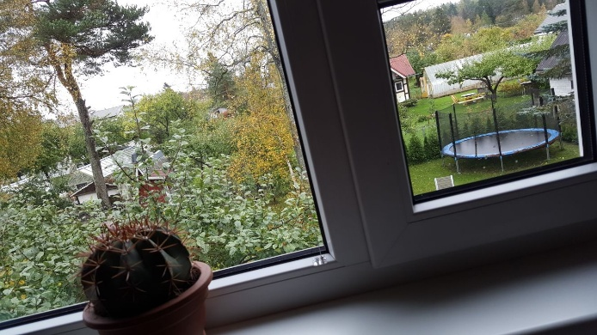(*A picture of their house)*

After lunch we went out with Danil, our Estonian friend, and he has shown us a little part of the old city and some important places of the town. Then we went to the bowling alley and we played bowling. It was fantastic!

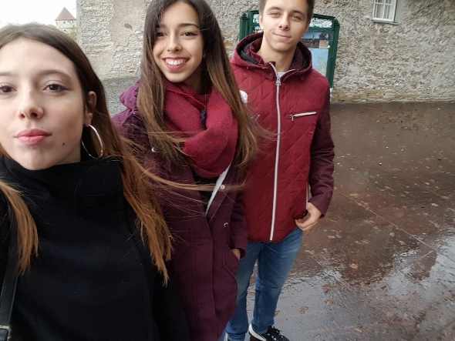(*Chiara, me and Danil)*

# *2nd DAY: MONDAY*

In the morning we went to the old town and we walked for a lot of time under the rain. The town was beautiful, full of colors and green and the houses had unusual shapes, I liked it!

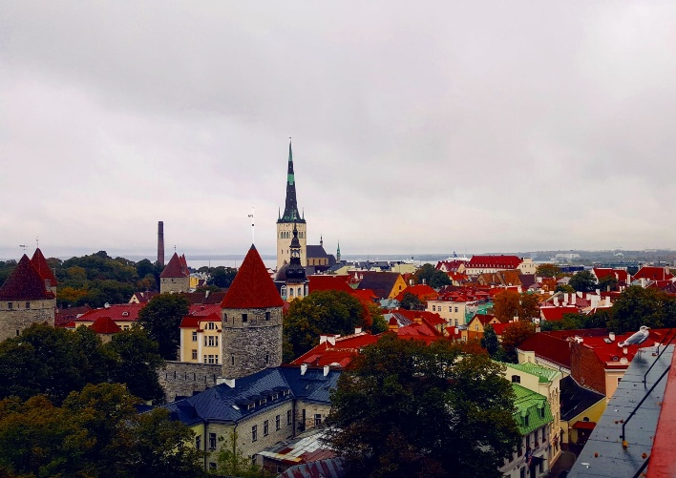(*The old town)*

After the city tour we went at school to eat for lunch, but it wasn’t so good.

Subsequently we had the rehearsal with teachers in a room of the school and then the groups of Estonian students have exhibited with typical dances and music to show us their traditions.

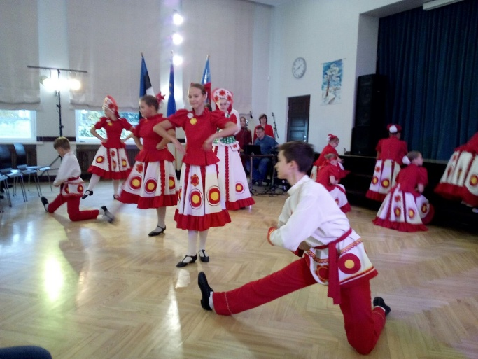(*A typical Estonian dance*)

In Monday afternoon our italian group had danced for a lot of time with some students of the school and our teachers played their instruments by improvisation. Sometimes the most beautiful things are born by chance.

In the evening we went with the other students to a restaurant called “Pizza Grande” to eat a pizza all together.

# *3rd DAY: TUESDAY*

The breakfast at family’s home was really good like every day. At home we have eaten healthy and the food was good every time.

In Tuesday morning we have visited a museum in Tallinn called “Kumu”, but it was a little bit boring, maybe because I was so tired and I didn’t pay a lot of attention.

*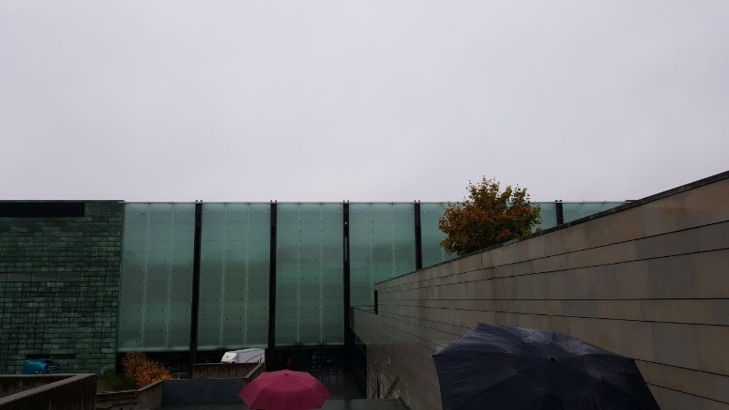(Kumu)*

For lunch we have eaten to the canteen in another school, far by our school.

Then we had the second rehearsal with the teachers.

Tuesday afternoon was the moment of the Turkey. Turkish students and their teachers have shown us their traditions with dance and music. I loved it and I payed a particular attention for their beautiful dresses. Me and three of my Italian friends also woke up and danced on their music. It was great!

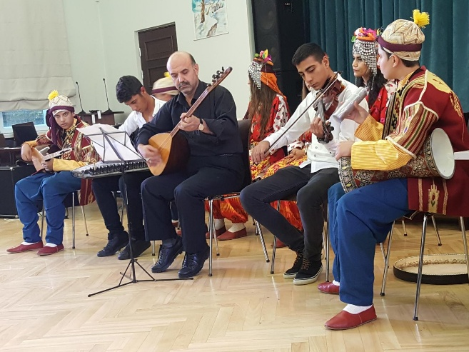(*Turkish exhibition)*

# *4th DAY: WEDNESDAY*

We spent Wednesday to Tartu, a beautiful city far 3 hours from Tallin.

We went to Tartu at about 9 am and we returned at about 7 pm. In my opinion it was the most interesting day.

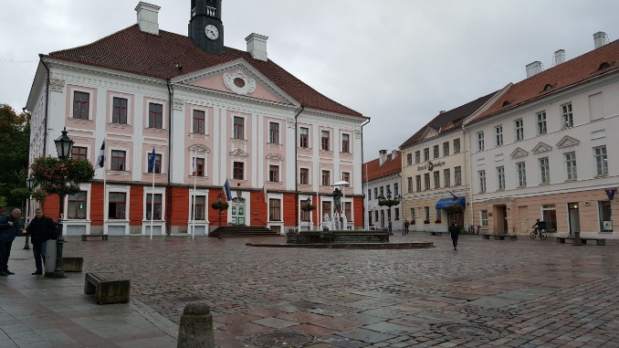(*Tartu)*

In the morning we have seen the “Estonian National Museum” projected in 2016. I loved its modern structure and its technological material. It was amazing to know the History of Estonian in this Museum because the stands were so interesting.

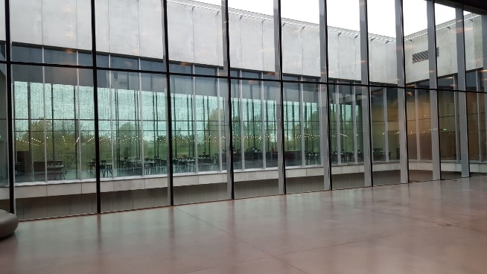(*Estonian National Museum)*

After lunch we went to visit the Vanemuine Theater, a very big and important theater in which there were all the things that a theater need, like dance rooms, the laundry, the dressing rooms, and a lot of rooms full of costumes of stage. I also tried one of the costumes, used in the performance “Mary Poppins”. It was amazing!

*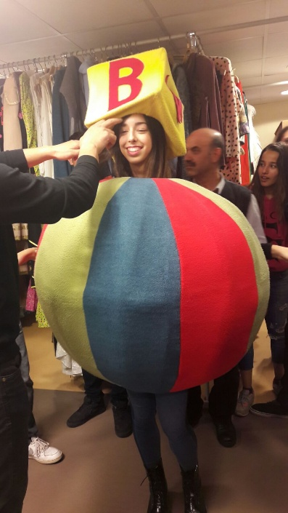(Me trying the costume)*

# *5th DAY: THURSDAY*

The last day was the most beautiful.

In the morning we had the last rehearsal. After lunch we were preparing for the performance; Italy was the first. At 3 o’clock the concert started. We were so excited and everything is gone right. We were so happy!

After the concert we went to the restaurant called “Lido” in which we had dinner for the last time all togheter.

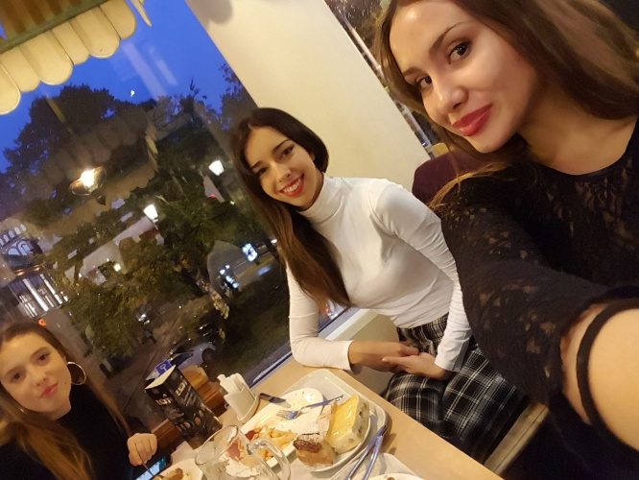(*Dinner at the restaurant)*

In the evening we have seen the Opera of Richard Wagner called “The flying Dutchman” that it was so difficult to understand because it was in German although the scenography and the special effects were amazing.

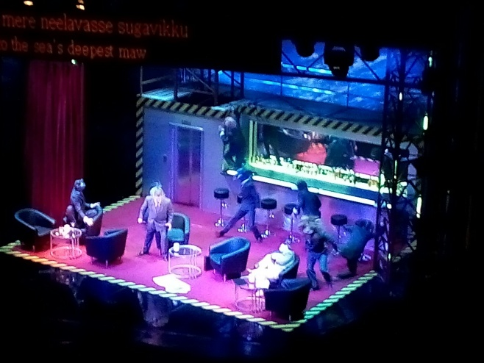(*The flying Dutchman)*

*Tatiana Leone, 5A*